Petroleum resources
Oil
The term oil encompasses the range of liquid hydrocarbons and includes crude oil and condensate:
- Crude oil is a naturally-occurring liquid consisting mainly of hydrocarbons derived from the thermal and chemical alteration of organic matter buried in sedimentary basins. It is formed as organic-rich rocks are buried and heated over geological time.
- Condensate is a liquid mixture of pentane and heavier hydrocarbons found in oil fields with associated gas or in gas fields. It is a gas in the subsurface reservoir, but condenses to form a liquid when produced and brought to the surface.
Australia has about 0.3 per cent of the world oil reserves. Most of Australia’s known remaining oil resources are condensate and liquefied petroleum gas (LPG) associated with giant offshore gas fields in the Browse, Carnarvon and Bonaparte basins. In addition oil resources are identified in the Perth, Canning, Amadeus, Cooper/Eromanga, Bowen/Surat, Otway, Bass and Gippsland basins.
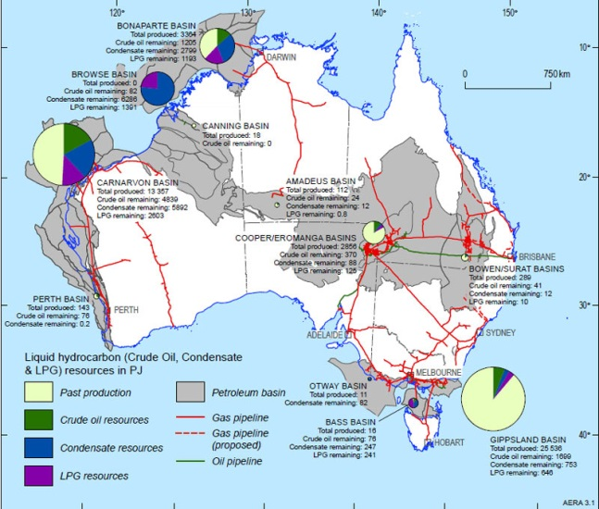

Australian crude oil, condensate and naturally-occurring LPG resources, infrastructure, past production and remaining
resources © Geoscience Australia.

Gas
Natural gas is a combustible mixture of hydrocarbon gases. It consists mainly of methane (CH₄), with varying levels of heavier hydrocarbons and other gases such as carbon dioxide. Natural gas is formed by the alteration of organic matter. This can be by biogenic or thermogenic processes. When accumulated in a subsurface reservoir that can be readily produced it is known as conventional gas.
Conventional gases (gas) fields can be dry (almost pure methane) or wet (associated with the “wet gas” components – ethane, propane, butanes and condensate). Dry gas has less energy content than wet gas. Conventional gas can also be found with oil in oil fields. Natural gas also occurs in more difficult to extract unconventional deposits, such as coal beds (coal seam gas), or in shales (shale gas), low quality reservoirs (tight gas), or as gas hydrates.
Liquid Natural Gas (LNG) is primarily composed of the lightest hydrocarbons, methane (CH₄) and ethane (C₂H₆); it is a gas at surface conditions but is cooled and compressed to a liquid for transport in LNG tankers to export markets. LNG is natural gas that is cooled to around –160°C until it forms a liquid, making it easier to transport.
Australia has significant gas resources, with gas being Australia’s third largest energy resource after coal and uranium. Conventional gas resources are widespread both on and offshore, occurring in fourteen different basins, but most of the resource is off the north-west margin in the Bonaparte, Browse and Carnarvon basins.
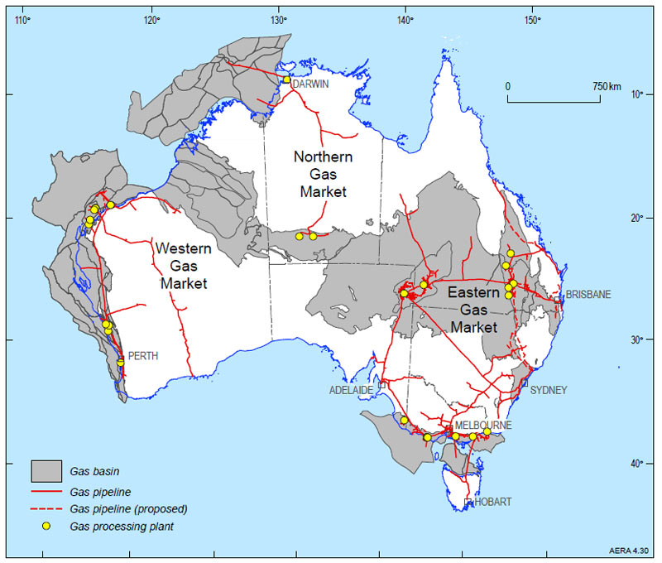
Australia’s gas facilities © Geoscience Australia
Coal seam gas
Coal Seam Gas (CSG) is a naturally occurring methane gas found in most coal seams and is similar to conventional natural gas. In Australia the commercial production of CSG commenced in 1996 in the Bowen Basin, Queensland. Since then production has increased rapidly, particularly during the first decade of the 21st century. CSG has now become an integral part of the gas industry in eastern Australia, particularly in Queensland.
Information about reserves of CSG has grown significantly, particularly in the Bowen and Surat basins in Queensland. In New South Wales reserves have been proven in the Sydney, Gunnedah, Clarence-Moreton and Gloucester basins. Exploration has been undertaken or is planned to be undertaken in other coal basins including the Galilee, Arckaringa, Perth and Pedirka basins.
A major driver for the growth in CSG was a decision in 2000 by the Queensland Government that required 13% of all power supplied to the state electricity grid to be generated by gas by 2005. That requirement has been increased to 15% by 2010 and 18% by 2020.
CSG reserves have grown to such an extent that a number of Liquid Natural Gas (LNG) plants have been proposed based on exports from Gladstone, Queensland.
Unconventional petroleum resources
Unconventional resources are natural resources which require greater than industry-standard levels of technology or investment to exploit. In the case of unconventional hydrocarbon resources, additional technology, energy and capital has to be applied to extract the gas or oil, replacing the natural action of the geological processes of the petroleum system.
Examples of unconventional oil resources include oil shales, oil sands, extra-heavy oil, gas-to-liquids and coal-to-liquids. Oil shale is an example where a thermally immature source rock has not generated and expelled hydrocarbons. Oil or tar sands occur where conventional crude oil has failed to be trapped at depth and has migrated near to the surface and has become degraded by evaporation, biodegradation and water washing to produce a viscous heavy oil residue.
In contrast to conventional gas reservoirs, natural gas can also be found in more difficult to extract unconventional deposits, such as coal beds (coal seam gas), or in shales (shale gas), low quality reservoirs (tight gas), or as gas hydrates. Unconventional gas accumulations reflect the failure or under-performance of the petroleum system.
- Shale gas and coal seam gas are examples where the natural gas is still within the source rock, not having migrated to a porous and permeable reservoir.
- Tight gas occurs within low permeability reservoir rocks, which are rocks with matrix porosities of 10 per cent or less and permeabilities of 0.1 millidarcy (mD) or less, exclusive of fractures. Tight gas can be regionally distributed (for example, basin-centred gas), rather than accumulated in a readily producible reservoir in a discrete structural closure as in a conventional gas field.
- Gas hydrates are naturally occurring ice-like solids (clathrates) in which water molecules trap gas molecules in deep-sea sediments and in and below the permafrost soils of the polar regions.
The recent developments of oil sands in Canada and of shale gas in the United States are examples where rising energy prices and technological development has facilitated the exploitation of unconventional hydrocarbon resources. In the Australian context, coal seam gas is the unconventional hydrocarbon resource that is most developed.

Oil shale
Oil shale is a fine-grained sedimentary rock containing large amounts of organic matter (kerogen), which can yield substantial quantities of hydrocarbons. Oil shale is essentially a petroleum source rock which has not undergone the complete thermal maturation required to convert organic matter to oil. In addition, the further geological processes of hydrocarbon migration and accumulation which produce conventional crude oil resources trapped in subsurface reservoirs has not occurred. The unconventional shale oil resource can be transformed into liquid hydrocarbons by mining, crushing, heating, processing and refining, or by in situ heating, oil extraction and refining. One tonne of commercial grade oil shale may yield from about 100 to 200 litres (L) of oil, that is approximately a half to one barrel of shale oil per tonne of oil shale.
Australia has a large unconventional and currently non-producing identified shale oil resource of 131 600PJ (22 390mmbbl) which could potentially contribute to future oil supply if economic and environmental challenges can be overcome. The majority of Australian shale oil resources of commercial interest are located in Queensland, in the vicinity of Gladstone and Mackay. Thick Cenozoic lacustrine oil shale deposits (lamosite) of commercial interest are predominantly in a series of narrow and deep extensional basins near Gladstone and Mackay. Oil shale deposits of varying quality also occur in New South Wales, Tasmania, and Western Australia in sedimentary sequences of Permian, Cretaceous and Cenozoic age.
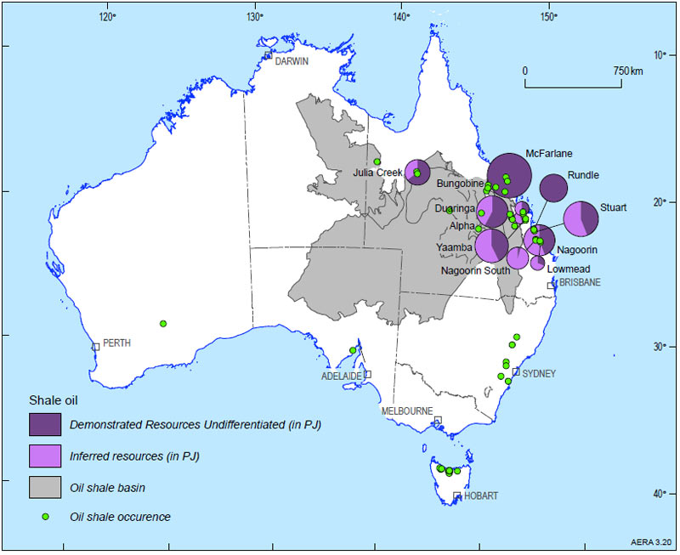
Distribution of Australian indicated shale oil resources © Geoscience Australia
Text and images sourced from: Petroleum resources © Commonwealth of Australia (Geoscience Australia) 2015. http://www.ga.gov.au/scientific-topics/energy/resources/petroleum-resources CC BY 4.0 creativecommons.org/licenses/by/4.0/

